**COMPARING THE LIGHT ABSORPTION EFFICIENCY OF SOLAR CELL COATED WITH ZINC OXIDE (ZnO) NANORODS TO THAT OF A NORMAL SOLAR CELL**

Jittin Mathew

**1. INTRODUCTION**

The world is changing rapidly and energy production has not been able to keep up with the demand (10 Trillion kWh in current time) and is expected to rise. According to the prediction of Energy Information Administration (EIA), the global energy demand will pummel to 35 Trillion kWh in 2035 [1]. Fossil fuels alone can’t give this mammoth of energy for the population and so we have to find solutions before it’s too late.

Current energy harvesting technologies are inefficient. Fossil fuels are being used more than ever for the growing need of energy. Centuries of burning fossil fuels have created some very specific problems which could spell disaster for us. Effects such as global warming due to greenhouse gas emissions, global climate change are the result of burning these polluting fuels. According to scientists, the global temperature will rise to 3 degrees before the turn of this century and our future generation will face its consequences. So, scientists around the world are thinking of alternative solutions that can satisfy this energy demand and also are cheap, clean, renewable and not environment destructive. There are many such sources such as geothermal energy, wind energy, fusion energy, solar energy etc. Out of these sources, solar energy is a sustainable alternative to fossil fuels. It is the most attractive solution as the sun is a massive factory of power. Every hour, the sun showers the earth enough energy to fulfill the global demand of energy for a year [2]. It has the potential to fulfill our energy demand for the generations to come. It is environment friendly, and accessible to all the countries and renewable source of energy.

Solar cells are used to convert Solar Energy into Electricity but there are two major drawbacks of silicon solar cells: efficiencies and their expensive manufacturing cost. It is observed that when the Solar light falls on the cell the incoming photons, or light, must have the right energy, called the band gap energy, to knock out an electron. If the photon has less energy than the band gap energy then it will pass through. If it has more energy than the band gap, then that extra energy will be wasted as heat. These two effects alone account for the loss of around 70 percent of the radiation energy incident on the cell. This issue of Silicon Solar cells unable to convert all the incoming light into usable energy because some of the light escaping back out of the cell into the air can be overcome to some extent by using coatings of Nanoparticles on the Solar cells. Due to its very small size, a large percentage of nanoparticles’ atoms re- side on their surfaces rather than in their interiors. Thus, increasing the surface interactions.

Nano-structured layers in thin film Silicon Solar cells can offer three important advantages [12]:

1. Due to multiple reflections, the effective optical path for absorption is much larger than the actual film thickness.

2. Light generated electrons and holes need to travel over a much shorter path and thus recombination losses are greatly reduced. As a result, the absorber layer thickness in nano-structured solar cells can be as thin as 150 nm instead of several micrometers in the traditional thin film solar cells.

3. The energy band gap of various layers can be made to the desired design value by varying the size of nano particles. This allows for more design flexibility in the absorber of solar cells.

In this project, I will analyze and compare the light absorption efficiency of a solar cell coated with Zinc oxide (ZnO) nanorods to that of a normal solar cell. I want to observe that using ZnO nanorods how much efficiency can be improved of a normal silicon solar cell.

**1.1 OBJECTIVES**

Nanotechnology is the latest buzz word in the world of technology and research. It is one of the very frontiers of science today and is very soon going to become more and more deeply embedded in everyday life. It is a fast-emerging field having vast potential for applications in the 21st century in all possible areas varying from engineering to medical and various other frontiers of science and technology. Moreover, the use of this field in environmental science is greatly appreciated such as water purification, food preservation and also solar energy to name a few. Using the properties of nanomaterials, we can overcome the drawbacks and limitations of Silicon Solar cell and use it in a better and more efficient way. The main motivations of this project are as follows:

1. Understanding the importance of Nanoscience and Nanomaterials.

2. Reviewing the various concepts in the Solar cell.

3. Understanding the Synthesis of Nanoparticles and growth of Nanorods on a Solar cell.

4. Highlighting the various advantages related to using Nanorods coated Solar cells.

**1.2 STRUCTURE OF THE PAPER**

The Section 2, introduces the concept of the Solar cell, the generation of charge carriers and the concept of depletion layer. In Section 3, I have analyzed the advantages of Zinc oxide (ZnO) nanoparticles and the procedure for cultivation of ZnO nanorods on the Solar cell are presented in Section 4. The Section 5, deals with the working of the circuit and the experimental setup. The Result with the readings, graph, calculations and observations are presented in the Section 6.

**2. THE SILICON SOLAR CELL**

The solar cell works based on the mechanism of quantum mechanics known as the photo- electric effect which was proved by Albert Einstein. When light particles known as photon also known as energy quanta strikes a photosensitive material, electrons are ejected from its outer shell in the valence band. Electrons absorb the energy photon and jumps from valence band to conduction band and become free electrons. If these electrons are made to flow in such a way that an electric current can be generated then it can be used to generate electrical power. Which is exactly what a solar cell does. It absorbs light and generates an electric current which can stored for further use.

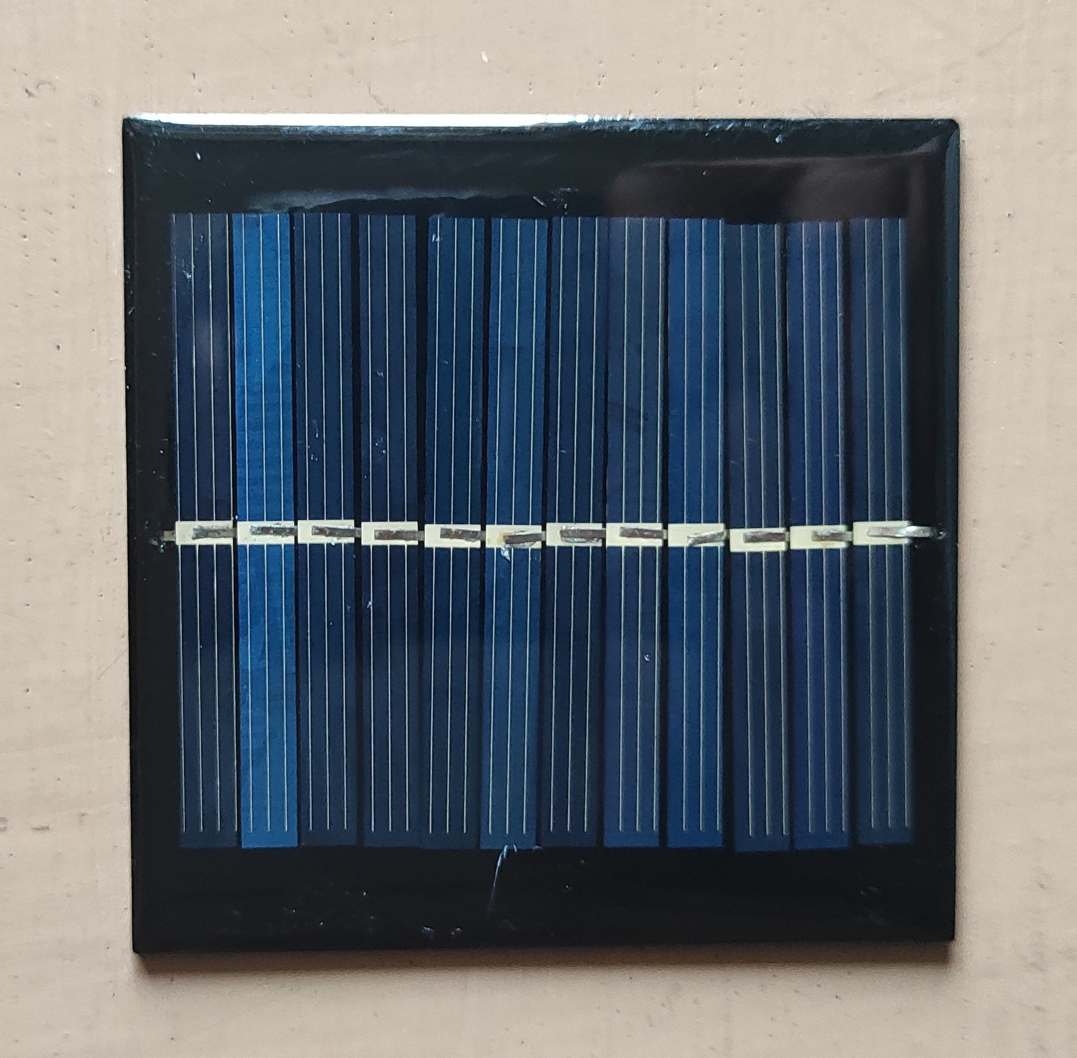

Figure 1: Normal Solar cell

The generation of charge carriers happen when a photon hits a piece of silicon. One of the following three things can happen:

The photon may pass straight through the silicon. This generally happens for lower energy photons.

The photon may reflect off the surface.

The photon may be absorbed by the silicon if the photon energy is higher than the silicon band gap value.

This generates an electron-hole pair and sometimes heat depending on the band structure.

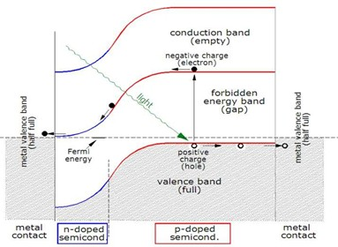

Figure 2: Band Diagram of Solar cell

Usually, electron bound to an atom are tightly bound in covalent bond with other neighboring atoms and are not free to move around. When photon energy is given to this electron, the electron excites and jumps from valance band to conduction band and is free to move around. This creates a deficiency in electrons in the network of covalent bonds. This is known as a hole. The presence of a missing covalent bond allows the bonded electrons of neighboring atoms to move into the “hole”, leaving another hole behind, thus propagating holes throughout the lattice. This effect generates electron-hole pairs.

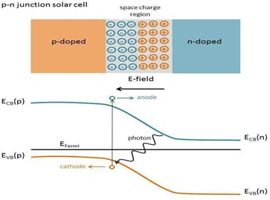

Figure 3: P-N Junction Solar cell

The most commonly known solar cell is configured as a large-area silicon p-n junction. p-n junction silicon cells are made by diffusing an n-type dopant into one side of a p-type wafer or vice-versa. When p-type and n-type silicon are placed near each other, diffusion of electron can occur from n-type to p-type and then recombine into the p-type silicon. As a result, an electric field is generated and it promotes charge flow known as drift current which opposes the indefinite diffusion of charge carriers. The region where electron and holes diffuse in the depletion region.

**3. ADVANTAGES OF ZnO NANOPARTICLES COATED SOLAR CELL**

ZnO has a direct wide band gap and large exciton energy at room temperature. It also has high charge carrier (electron) mobility, transparency to visible light, and can be made highly conductive by doping, stability against photo-corrosion, are available at low-cost, are eco-friendly and has more flexibility in synthesis due to its advantageous morphology. [3,10]. ZnO is a versatile functional material having a diverse group of growth morphologies, such as nanocombs, nanorings, nanohelixes, nanosprings, nanobelts, nanowires and nanocages. Besides the conventional one-dimensional (1D) nanorods, nanowires and nanotubes, a diversity of 2D nanomaterials of ZnO such as nanodisks, nanosheets, nanoplates and nanofilms have emerged recently [4,5]. Therefore, ZnO has the advantage of easy synthesis of controlled nanostructures over other metal oxides[6]. The photoelectrode films with nanostructured ZnO can significantly enhance solar cell performance by offering a large surface area for dye adsorption, direct transport pathways for photoexcited electrons, and efficient scattering centers for enhanced light-harvesting efficiency [5,8].

**4. PROCEDURE FOR CULTIVATION OF ZnO NANORODS ON THE SOLAR CELL**

The procedure of growing ZnO Nanorods on a Solar cell consists of the following points:

1. Synthesis of ZnO Nanoparticles

2. Seeding of ZnO Nanoparticles on the Solar cell

3. Synthesis and growth of ZnO Nanorods on the Solar cell

**1. Synthesis of ZnO Nanoparticles**

Solvent: Ethanol

Salt: Zn(CH3COO)2 . 2H2O, NaOH

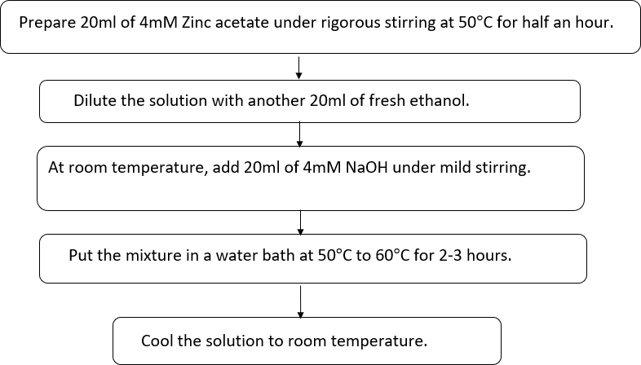

Figure 4: Flowchart of the procedure for Synthesis of ZnO Nanoparticles

**Calculations for Zn(CH3COO)2 .2H2O:**

Formula weight(FW)= 219.51 gm/mol

Amount= FW X concentration X amount of solvent

= 219.51X20X10-3X4X10-3 =0.01756 gm

**Calculations for NaOH:**

Formula weight (FW)=39.997 gm/mol Amount of NaOH= 0.0032gm

**2**. **Seeding of ZnO Nanoparticles on the Solar cell:**

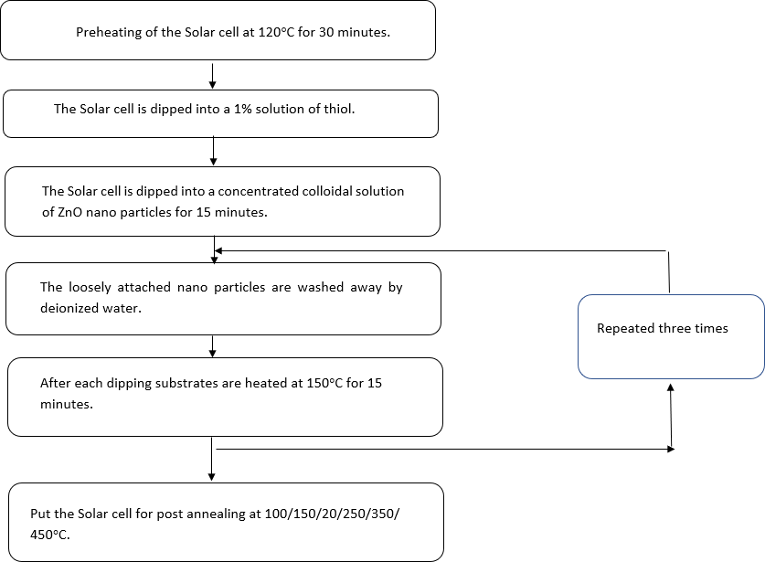

Figure 5: Flowchart of the procedure for Seeding of ZnO Nanoparticles on the Solar cell

**3. Synthesis and growth of ZnO Nanorods on the Solar cell:**

Nanorods are grown in a sealed chemical bath containing equimolar (10mM) solution of Zinc Nitrate Hexahydrate (Zn (NO3)2. 6H2O) and Hexamethylene Tetramine(C6H12N4) at 90*◦*C.

Solvent: Deionized water

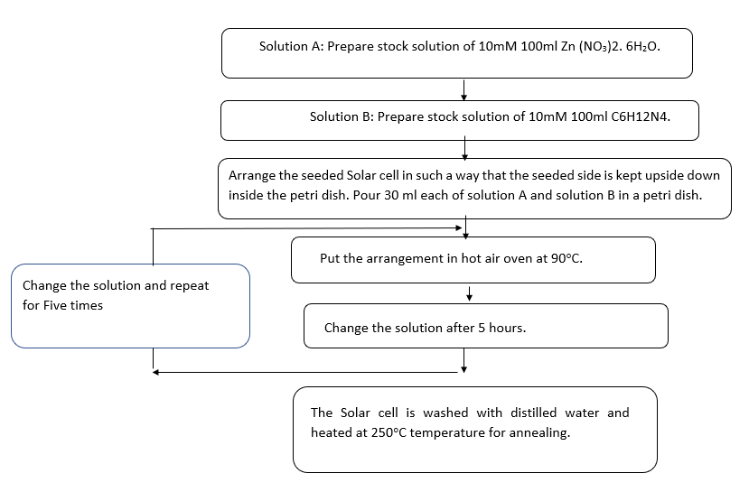

Figure 6: Flowchart of the procedure for Synthesis of ZnO Nanorods on the Solar cell

**Calculations:**

FW of Zn(NO3)2 . 6H2O=297.5 gm/mol FW of C6H12N4=140.186 gm/mol Amount of Zn(NO3)2 . 6H2O=0.297 gm Amount of C6H12N4=0.14086 gm

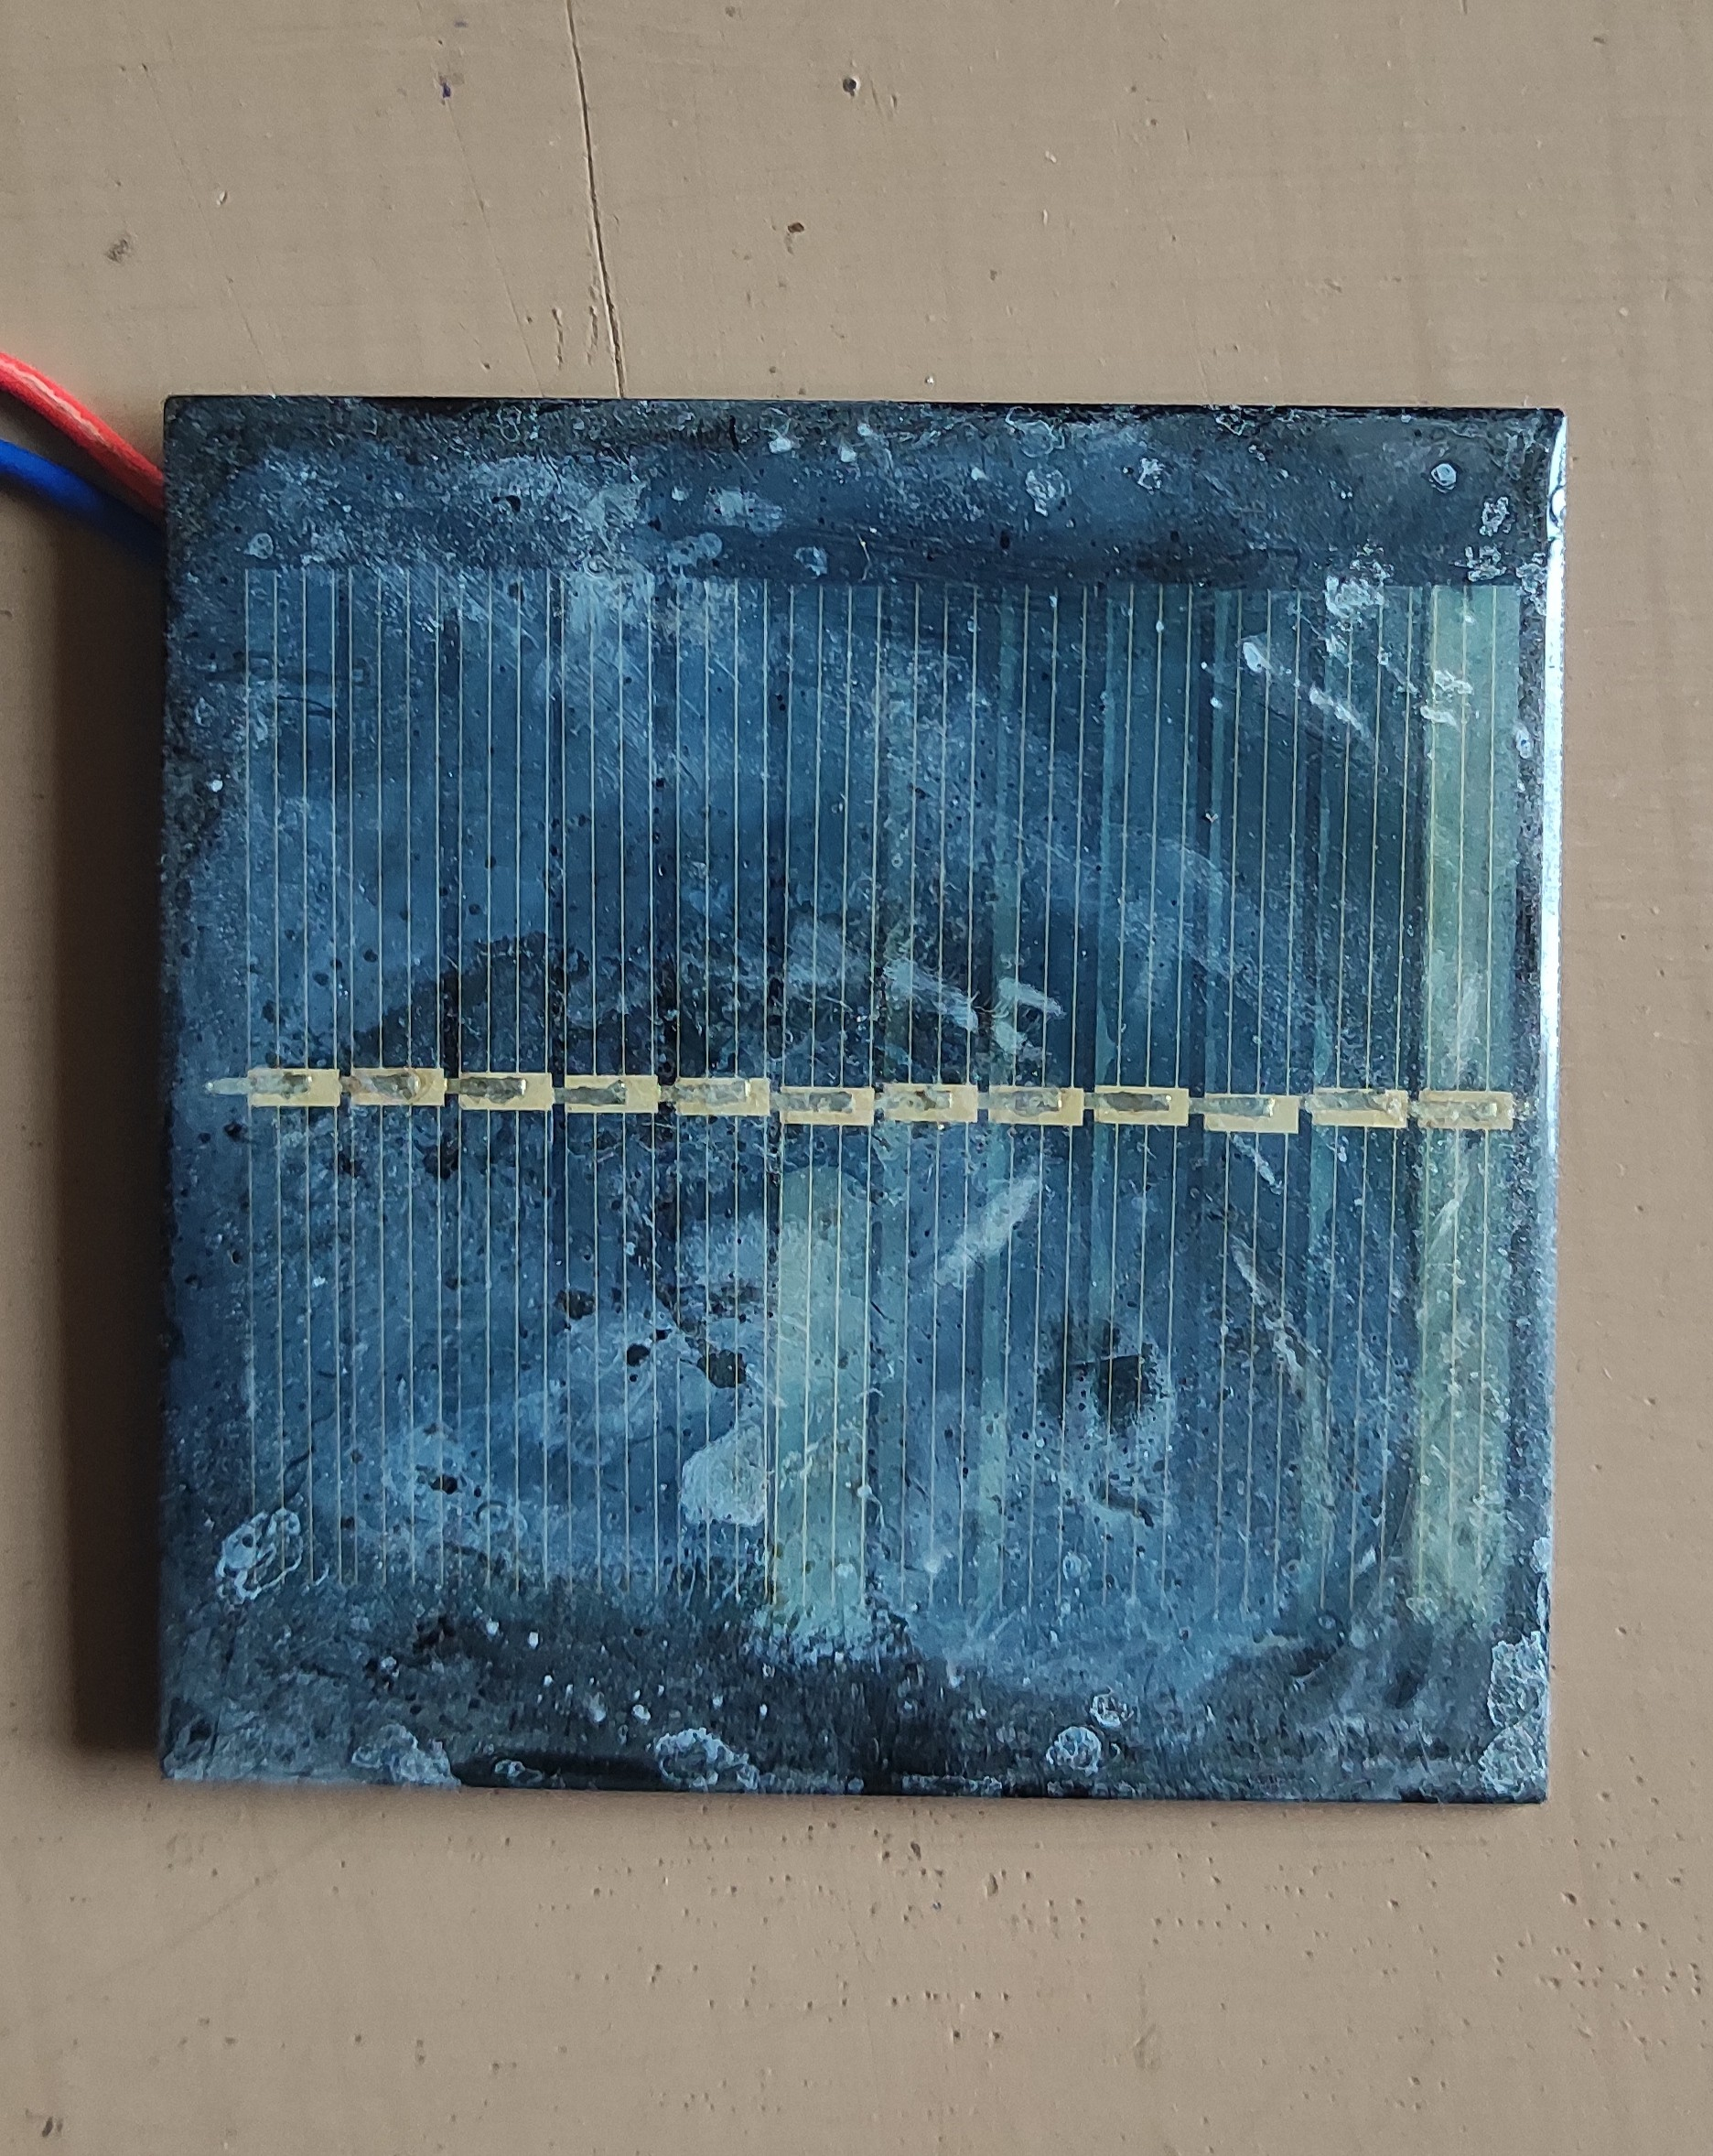

Figure 7: Solar cell coated with Zinc oxide (ZnO) nanorods

**THE WORKING OF THE CIRCUIT:**

A voltage divider circuit is connected to measure the voltage-current characteristics of the solar cell under an incandescent light bulb.

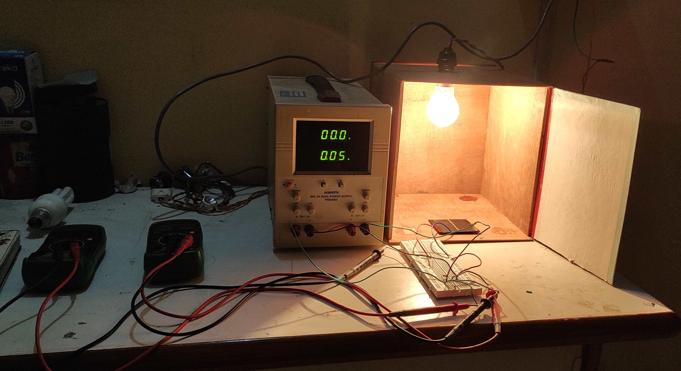

Figure 8: Experimental Setup

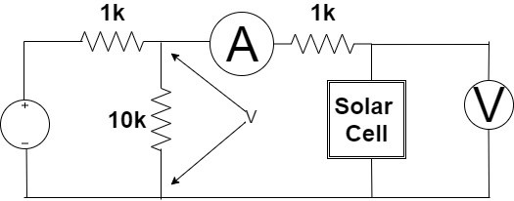

Figure 9: Circuit Diagram

**5. RESULT**

**READINGS:**

**Table 1: Under Light on Normal Solar cell.**

|  |  |  |
| --- | --- | --- |
| **V-I Characteristics** | | |
| **Sr No.** | **VOLTAGE (volts)** | **CURRENT (mA)** |
| 1 | -5 | -11.46 |
| 2 | -4.8 | -11.21 |
| 3 | -4.6 | -10.96 |
| 4 | -4.4 | -10.71 |
| 5 | -4.2 | -10.5 |
| 6 | -4 | -10.29 |
| 7 | -3.8 | -10.08 |
| 8 | -3.6 | -9.85 |
| 9 | -3.4 | -9.64 |
| 10 | -3.2 | -9.44 |
| 11 | -3 | -9.23 |
| 12 | -2.8 | -9 |
| 13 | -2.6 | -8.85 |
| 14 | -2.4 | -8.61 |
| 15 | -2.2 | -8.1 |
| 16 | -2 | -7.85 |
| 17 | -1.8 | -7.62 |
| 18 | -1.6 | -7.45 |
| 19 | -1.4 | -7.26 |
| 20 | -1.2 | -7.1 |
| 21 | -1 | -7.04 |
| 22 | -0.8 | -6.88 |
| 23 | -0.6 | -6.71 |
| 24 | -0.4 | -6.5 |
| 25 | -0.2 | -6.3 |
| 26 | 0 | -6.06 |
| 27 | 0.2 | -5.98 |
| 28 | 0.4 | -5.75 |
| 29 | 0.6 | -5.53 |
| 30 | 0.8 | -5.33 |
| 31 | 1 | -5.12 |
| 32 | 1.2 | -4.92 |
| 33 | 1.4 | -4.68 |
| 34 | 1.6 | -4.47 |
| 35 | 1.8 | -4.26 |
| 36 | 2 | -4.05 |
| 37 | 2.2 | -3.84 |
| 38 | 2.4 | -3.64 |
| 39 | 2.6 | -3.54 |
| 40 | 2.8 | -3.34 |
| 41 | 3 | -3.14 |
| 42 | 3.2 | -2.93 |
| 43 | 3.4 | -2.73 |
| 44 | 3.6 | -2.54 |
| 45 | 3.8 | -2.33 |
| 46 | 4 | -2.12 |
| 47 | 4.2 | -1.93 |
| 48 | 4.4 | -1.68 |
| 49 | 4.6 | -1.52 |
| 50 | 4.8 | -1.32 |
| 51 | 5 | -1.12 |
| 52 | 5.2 | -0.93 |
| 53 | 5.4 | -0.73 |
| 54 | 5.6 | -0.53 |
| 55 | 5.8 | -0.32 |
| 56 | 6 | -0.13 |
| 57 | 6.17 | 0 |
| 58 | 6.2 | 0.03 |
| 59 | 6.4 | 0.32 |
| 60 | 6.6 | 0.54 |
| 61 | 6.8 | 0.74 |
| 62 | 7 | 0.94 |
| 63 | 7.2 | 1.07 |
| 64 | 7.4 | 1.28 |
| 65 | 7.6 | 1.48 |
| 66 | 7.8 | 1.7 |
| 67 | 8 | 1.9 |
| 68 | 8.2 | 2.12 |
| 69 | 8.4 | 2.33 |
| 70 | 8.6 | 2.54 |
| 71 | 8.8 | 2.54 |
| 72 | 9 | 2.75 |
| 73 | 9.2 | 2.96 |
| 74 | 9.4 | 3.16 |
| 75 | 9.6 | 3.39 |
| 76 | 9.8 | 3.6 |
| 77 | 10 | 3.8 |
| 78 | 10.2 | 4.01 |
| 79 | 10.4 | 4.21 |
| 80 | 10.6 | 4.41 |
| 81 | 10.8 | 4.62 |
| 82 | 11 | 4.83 |
| 83 | 11.2 | 5.03 |
| 84 | 11.4 | 5.23 |
| 85 | 11.6 | 5.43 |
| 86 | 11.8 | 5.63 |
| 87 | 12 | 5.85 |
| 88 | 12.2 | 6.05 |
| 89 | 12.4 | 6.25 |
| 90 | 12.6 | 6.44 |
| 91 | 12.8 | 6.66 |
| 92 | 13 | 6.85 |
| 93 | 13.2 | 7.07 |
| 94 | 13.4 | 7.29 |
| 95 | 13.6 | 7.48 |
| 96 | 13.8 | 7.68 |
| 97 | 14 | 7.88 |
| 98 | 14.2 | 8.07 |
| 99 | 14.4 | 8.29 |
| 100 | 14.6 | 8.49 |
| 101 | 14.8 | 8.7 |
| 102 | 15 | 8.9 |

**Table 2: Under Darkness on Normal Solar cell.**

|  |  |  |
| --- | --- | --- |
| **V-I Characteristics** | | |
| **Sr No.** | **VOLTAGE (volts)** | **CURRENT (uA)** |
| 1 | -5 | -10.7 |
| 2 | -4.8 | -9.5 |
| 3 | -4.6 | -8.8 |
| 4 | -4.4 | -8 |
| 5 | -4.2 | -7.2 |
| 6 | -4 | -6.7 |
| 7 | -3.8 | -6 |
| 8 | -3.6 | -5.6 |
| 9 | -3.4 | -5.2 |
| 10 | -3.2 | -4.9 |
| 11 | -3 | 4.5 |
| 12 | -2.8 | -4.2 |
| 13 | -2.6 | -4 |
| 14 | -2.4 | -3.6 |
| 15 | -2.2 | -3.4 |
| 16 | -2 | -3.2 |
| 17 | -1.8 | -2.8 |
| 18 | -1.6 | -2.6 |
| 19 | -1.4 | -2.4 |
| 20 | -1.2 | -1.8 |
| 21 | -1 | -1.6 |
| 22 | -0.8 | -1.5 |
| 23 | -0.6 | -1.3 |
| 24 | -0.4 | -1.1 |
| 25 | -0.2 | -0.8 |
| 26 | 0 | -0.5 |
| 27 | 0.2 | -0.8 |
| 28 | 0.4 | -1.1 |
| 29 | 0.6 | 0.4 |
| 30 | 0.8 | 1 |
| 31 | 1 | 1.8 |
| 32 | 1.2 | 2.9 |
| 33 | 1.4 | 4.3 |
| 34 | 1.6 | 5.9 |
| 35 | 1.8 | 8 |
| 36 | 2 | 10.6 |
| 37 | 2.2 | 14 |
| 38 | 2.4 | 18.2 |
| 39 | 2.6 | 23.6 |
| 40 | 2.8 | 30 |
| 41 | 3 | 38.8 |
| 42 | 3.2 | 49.2 |
| 43 | 3.4 | 62.4 |
| 44 | 3.6 | 78.3 |
| 45 | 3.8 | 98 |
| 46 | 4 | 120.8 |
| 47 | 4.2 | 147.8 |
| 48 | 4.4 | 179.1 |
| 49 | 4.6 | 263 |
| 50 | 4.8 | 323 |
| 51 | 5 | 387 |
| 52 | 5.2 | 466 |
| 53 | 5.4 | 546 |
| 54 | 5.6 | 636 |
| 55 | 5.8 | 740 |
| 56 | 6 | 849 |
| 57 | 6.2 | 957 |
| 58 | 6.4 | 1076 |
| 59 | 6.6 | 1202 |
| 60 | 6.8 | 1338 |
| 61 | 7 | 1476 |
| 62 | 7.2 | 1608 |
| 63 | 7.4 | 1760 |
| 64 | 7.6 | 1900 |
| 65 | 7.8 | 2180 |
| 66 | 8 | 2340 |
| 67 | 8.2 | 2500 |
| 68 | 8.4 | 2670 |
| 69 | 8.6 | 2840 |

**Table 3: Under Light on Solar cell coated with ZnO nanorods.**

|  |  |  |
| --- | --- | --- |
| **V-I Characteristics** | | |
| **Sr No.** | **VOLTAGE (volts)** | **CURRENT (mA)** |
| 1 | -5 | -11.46 |
| 2 | -4.8 | -11.10 |
| 3 | -4.6 | -10.88 |
| 4 | -4.4 | -10.64 |
| 5 | -4.2 | -10.38 |
| 6 | -4 | -10.16 |
| 7 | -3.8 | -9.94 |
| 8 | -3.6 | -9.72 |
| 9 | -3.4 | -9.48 |
| 10 | -3.2 | -9.27 |
| 11 | -3 | -9.05 |
| 12 | -2.8 | -8.87 |
| 13 | -2.6 | -8.67 |
| 14 | -2.4 | -8.46 |
| 15 | -2.2 | -8.25 |
| 16 | -2 | -8.04 |
| 17 | -1.8 | -7.83 |
| 18 | -1.6 | -7.63 |
| 19 | -1.4 | -7.43 |
| 20 | -1.2 | -7.22 |
| 21 | -1 | -7.02 |
| 22 | -0.8 | -6.81 |
| 23 | -0.6 | -6.61 |
| 24 | -0.4 | -6.41 |
| 25 | -0.2 | -6.21 |
| 26 | 0 | -5.96 |
| 27 | 0.2 | -5.76 |
| 28 | 0.4 | -5.56 |
| 29 | 0.6 | -5.36 |
| 30 | 0.8 | -5.16 |
| 31 | 1 | -4.96 |
| 32 | 1.2 | -4.76 |
| 33 | 1.4 | -4.56 |
| 34 | 1.6 | -4.36 |
| 35 | 1.8 | -4.16 |
| 36 | 2 | -3.94 |
| 37 | 2.2 | -3.75 |
| 38 | 2.4 | -3.54 |
| 39 | 2.6 | -3.34 |
| 40 | 2.8 | -3.14 |
| 41 | 3 | -2.96 |
| 42 | 3.2 | -2.76 |
| 43 | 3.4 | -2.56 |
| 44 | 3.6 | -2.38 |
| 45 | 3.8 | -2.19 |
| 46 | 4 | -1.99 |
| 47 | 4.2 | -1.80 |
| 48 | 4.4 | -1.62 |
| 49 | 4.6 | -1.42 |
| 50 | 4.8 | -1.22 |
| 51 | 5 | -1.02 |
| 52 | 5.2 | -0.82 |
| 53 | 5.4 | -0.62 |
| 54 | 5.6 | -0.42 |
| 55 | 5.8 | -0.22 |
| 56 | 6 | -0.03 |
| 57 | 6.03 | 0 |
| 58 | 6.2 | 0.13 |
| 59 | 6.4 | 0.33 |
| 60 | 6.6 | 0.54 |
| 61 | 6.8 | 0.74 |
| 62 | 7 | 0.93 |
| 63 | 7.2 | 1.14 |
| 64 | 7.4 | 1.33 |
| 65 | 7.6 | 1.53 |
| 66 | 7.8 | 1.73 |
| 67 | 8 | 1.93 |
| 68 | 8.2 | 2.13 |
| 69 | 8.4 | 2.33 |
| 70 | 8.6 | 2.53 |
| 71 | 8.8 | 2.73 |
| 72 | 9 | 2.93 |
| 73 | 9.2 | 3.12 |
| 74 | 9.4 | 3.32 |
| 75 | 9.6 | 3.52 |
| 76 | 9.8 | 3.72 |
| 77 | 10 | 3.92 |
| 78 | 10.2 | 4.12 |
| 79 | 10.4 | 4.32 |
| 80 | 10.6 | 4.52 |
| 81 | 10.8 | 4.72 |
| 82 | 11 | 4.92 |
| 83 | 11.2 | 5.12 |
| 84 | 11.4 | 5.32 |
| 85 | 11.6 | 5.52 |
| 86 | 11.8 | 5.72 |
| 87 | 12 | 5.92 |
| 88 | 12.2 | 6.12 |
| 89 | 12.4 | 6.32 |
| 90 | 12.6 | 6.52 |
| 91 | 12.8 | 6.72 |
| 92 | 13 | 6.92 |
| 93 | 13.2 | 7.13 |
| 94 | 13.4 | 7.33 |
| 95 | 13.6 | 7.53 |
| 96 | 13.8 | 7.74 |
| 97 | 14 | 7.94 |
| 98 | 14.2 | 8.13 |
| 99 | 14.4 | 8.34 |
| 100 | 14.6 | 8.54 |
| 101 | 14.8 | 8.74 |
| 102 | 15 | 8.94 |

**Table 4: Under Darkness on Solar cell coated with ZnO nanorods.**

|  |  |  |
| --- | --- | --- |
| **V-I Characteristics** | | |
| **Sr No.** | **VOLTAGE (volts)** | **CURRENT (uA)** |
| 1 | -5 | -6.7 |
| 2 | -4.8 | -6.2 |
| 3 | -4.6 | -5.7 |
| 4 | -4.4 | -5.1 |
| 5 | -4.2 | -4.7 |
| 6 | -4 | -4.3 |
| 7 | -3.8 | -4 |
| 8 | -3.6 | -3.7 |
| 9 | -3.4 | -3.4 |
| 10 | -3.2 | -3.1 |
| 11 | -3 | -2.9 |
| 12 | -2.8 | -2.6 |
| 13 | -2.6 | -2.4 |
| 14 | -2.4 | -2.2 |
| 15 | -2.2 | -1.9 |
| 16 | -2 | -1.7 |
| 17 | -1.8 | -1.5 |
| 18 | -1.6 | -1.3 |
| 19 | -1.4 | -1.2 |
| 20 | -1.2 | -1 |
| 21 | -1 | -0.9 |
| 22 | -0.8 | -0.7 |
| 23 | -0.6 | -0.5 |
| 24 | -0.4 | -0.3 |
| 25 | -0.2 | -1 |
| 26 | 0 | 0 |
| 27 | 0.2 | 0.1 |
| 28 | 0.4 | 0.6 |
| 29 | 0.6 | 1.1 |
| 30 | 0.8 | 1.8 |
| 31 | 1 | 2.8 |
| 32 | 1.2 | 4 |
| 33 | 1.4 | 5.6 |
| 34 | 1.6 | 7.6 |
| 35 | 1.8 | 10 |
| 36 | 2 | 13.2 |
| 37 | 2.2 | 17.2 |
| 38 | 2.4 | 22.8 |
| 39 | 2.6 | 29.1 |
| 40 | 2.8 | 37.4 |
| 41 | 3 | 48 |
| 42 | 3.2 | 62 |
| 43 | 3.4 | 79.3 |
| 44 | 3.6 | 99.6 |
| 45 | 3.8 | 125.9 |
| 46 | 4 | 156 |
| 47 | 4.2 | 190.7 |
| 48 | 4.4 | 280 |
| 49 | 4.6 | 339 |
| 50 | 4.8 | 409 |
| 51 | 5 | 491 |
| 52 | 5.2 | 578 |
| 53 | 5.4 | 675 |
| 54 | 5.6 | 776 |
| 55 | 5.8 | 883 |
| 56 | 6 | 1007 |
| 57 | 6.2 | 1117 |
| 58 | 6.4 | 1240 |
| 59 | 6.6 | 1378 |
| 60 | 6.8 | 1500 |
| 61 | 7 | 1640 |
| 62 | 7.2 | 1778 |
| 63 | 7.4 | 1921 |
| 64 | 7.6 | 2210 |
| 65 | 7.8 | 2360 |
| 66 | 8 | 2520 |
| 67 | 8.2 | 2690 |
| 68 | 8.4 | 2860 |
| 69 | 8.6 | 3030 |

**GRAPH:**

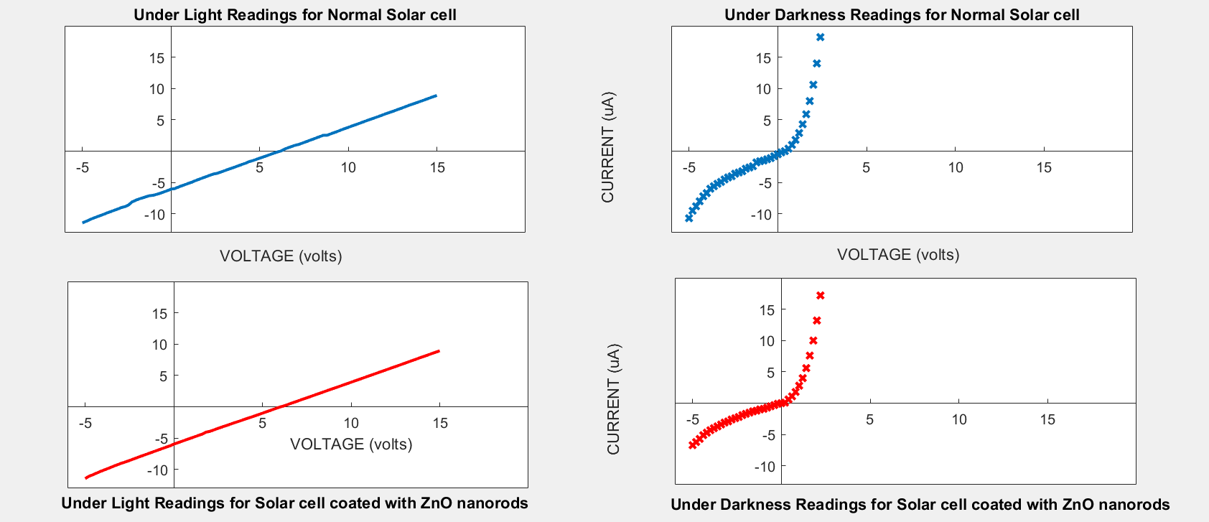

Figure 10: Comparing the V-I Characteristics of the Solar cell coated with ZnO nanorods to that of a normal Solar cell

**MATLAB CODE FOR PLOTTING OF THE GRAPH:**

voltage = Lnormal(:,1);

current = Lnormal(:,2);

subplot(2,2,1)

plot(voltage,current,'LineWidth',2)

title('Under Light Readings for Normal Solar cell')

xlabel('VOLTAGE (volts)')

ylabel('CURRENT (mA)')

axis ([-6 9 -13 5]);

voltage = Dnormal(:,1);

current = Dnormal(:,2);

subplot(2,2,2)

plot(voltage,current,'x','LineWidth',2)

title('Under Darkness Readings for Normal Solar cell')

xlabel('VOLTAGE (volts)')

ylabel('CURRENT (uA)')

axis ([-6 9 -13 5])

voltage = LZno(:,1);

current = LZno(:,2);

subplot(2,2,3)

plot(voltage,current,'r','LineWidth',2)

title('Under Light Readings for Solar cell coated with ZnO nanorods')

xlabel('VOLTAGE (volts)')

ylabel('CURRENT (mA)')

axis ([-6 9 -13 5])

voltage =DZno(:,1);

current = DZno(:,2);

subplot(2,2,4)

plot(voltage,current,'rx','LineWidth',2)

title('Under Darkness Readings for Solar cell coated with ZnO nanorods')

xlabel('VOLTAGE (volts)')

ylabel('CURRENT (uA)')

axis ([-6 9 -13 5])

**CALCULATIONS:**

**Short Circuit Current:** The short circuit current Isc is the highest current that can be drawn from a solar cell when the cell voltage is zero. At this point, the power is also zero.

Isc= Imax at (V = 0)

**For Normal Solar cell, Isc= 0.00606 Ampere**

**For ZnO nanorods coated Solar cell, Isc= 0.00596 Ampere**

**Open Circuit Potential:** The open circuit potential Voc is the highest voltage of a solar cell at a given light intensity. It is also the potential where current flow through a solar cell is zero.

Voc= Vmax at (I = 0)

**For Normal Solar cell, Voc= 6.17 Volts**

**For ZnO nanorods coated Solar cell, Voc= 6.03 Volts**

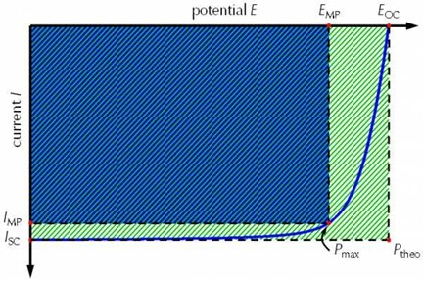

Figure 11: Curve showing maximum power with Fill Factor

**Power:** The generated power can be calculated by using the following equation

Pmax= Vmax × Imax

**For Normal Solar cell, Vmax= 3 Volts, Imax= 0.00314 Ampere and Pmax= 0.00942 Watts**

**For ZnO nanorods coated Solar cell, Vmax= 3 Volts, Imax= 0.00296 Ampere and Pmax= 0.00888 Watts**

**Fill Factor:** The Fill factor (FF) of a cell is an important parameter which specifies the overall capabilities of a cell. It describes the quality and idealness of a solar cell. It is also known as Diode equation.

The Fill factor is the ratio of maximum generated power Pmax to theoretical power maximum P of a solar cell. The general formula to calculate fill factor (FF) is

FF = (Vmax × Imax) / (Voc × Isc )

**For Normal Solar cell, FF= 0.2519376**

**For ZnO nanorods coated Solar cell, FF= 0.2470867**

**Efficiency:** The power conversion efficiency is the ratio between maximum generated power Pmax and electrical input power Pin from the light source.

Pin can be calculated using a lux meter. Efficiency = Pmax / Pin×100%

**For Normal Solar cell, Pmax= 0.00942 Watts, Pin=0.08427 Watts and Efficiency = 11.1%**

**For ZnO nanorods coated Solar cell, Pmax= 0.00888 Watts, Pin= 0.08427 Watts and Efficiency = 10.5%**

**OBSERVATION:**

1. While comparing the light absorption efficiency of solar cell coated with zinc oxide nanorods to that of a normal solar cell, it was observed that the efficiency of solar cell coated with Zinc oxide (ZnO) nanorods was less than the normal solar cell which was not expected. This may be due to the presence of the thick white residue from the synthesis process of nanorods on the Solar cell, obstructing the light from been absorbed throughout the whole surface. Thus, limiting the light absorbing efficiency of the solar cell coated with Zinc oxide (ZnO) nanorods.

2. It was also observed that the areas, with the presence of Zinc oxide (ZnO) nanorods on the Solar cell showed hydrophobic properties.

**6. CONCLUSION**

Thus through this project, I was able to analyze and compare the light absorption efficiency of a solar cell coated with Zinc oxide (ZnO) nanorods to that of a normal solar cell. The observation encountered were as follows:

The light absorption efficiency was compared between the Normal Solar cell and the same Solar cell coated with Zinc Oxide (ZnO) nanorods. Theoretically, **the efficiency should have been greater in the ZnO coated Solar cell but do the presence of the thick white residue from the synthesis process of nanorods on the Solar cell, obstructing the light from been absorbed throughout the whole surface, practically it was not observed**.

Further it was observed that **the areas, with the presence of Zinc oxide (ZnO) nanorods on the Solar cell showed hydrophobic properties**. This property could be further researched and utilized to produce dust free Solar cells.

**REFERENCES**

1. US Energy Information Administration, International Energy Outlook, 2010

2. Q Zhang, G Cao, “Nanostructured photoelectrodes for dye-sensitized solar cells.” Nano Today, vol. 6, no. 1, pp. 91-109, 2011

3. K. Keis, L. Vayssieres, H. Rensmo, S. E. Lindquist, and A. Hagfeldt, “Photoelectrochemical properties of nano to microstructured ZnO electrodes,” Journal of the Electrochemical Society, vol. 148, no. 2, pp. A149–A155, 2001.

4. P. Y. Wu, J. Pike, F. Zhang, and S. W. Chan, “Low- temperature synthesis of zinc oxide nanoparticles,” International Journal of Applied Ceramic Technology, vol. 3, no. 4, pp. 272– 278, 2006.

5. Q. Zhang, C. S. Dandeneau, X. Zhou, and C. Cao, “ZnO nanostructures for dye-sensitized solar cells,” Advanced Materials, vol. 21, no. 41, pp. 4087–4108, 2009.

6. Z. Zhang, M. Lu, H. Xu, and W. S. Chin, “Shape- controlled synthesis of zinc oxide: a simple method for the preparation of metal oxide nanocrystals in non-aqueous medium,” Chemistry: A European Journal, vol.13, no. 2, pp. 632–638, 2007.

7. S. Baruah and J. Dutta, “Hydrothermal growth of ZnO nanostructures,” Science and Technology of Advanced Materials 10.1 (2009): 013001

8. Y. Kang, D. Liang, S. Mehra, Y. Huo, Y. Chen, M. G. Christoforo, A. Salleo and J. S. Harris, “Efficiency Enhancement of Gallium Arsenide Photovoltaics Using Solution-Processed Zinc Oxide Nanoparticle Light Scattering Layers,” Journal of Nanomaterials, Hindawi Publishing Corporation, vol. 2015, article id 263734, 2015.

9. R. Tala-ighil, “Nanomaterials in Solar cells,” Handbook of Nanoelectrochemistry, Springer International Publishing Switzerland, pp.1–18, 2015.

10. A. Wibowo, M. A. Marsudi, M. I. Amal, M. B. Ananda, R. Stephanie, H. Ardy and L. J. Diguna, “ZnO nanostructured materials for emerging solar cell applications,” Royal Society of Chemistry Advances, vol. 10, issue. 70, 42838, 2020.

11. K. Al. Abdullah, S. Awad, J. Zaraket and C. Salame, “Synthesis of ZnO Nanopowders by Using Sol-Gel and Studying Their Structural and Electrical Properties at Different Temperature,” Energy Procedia vol. 119, pp. 565-570, 2017.

12. V. K. Sethi, P. Shukla, M. Pandey, “Use of Nanotechnology in Solar PV Cell,” International Journal of Chemical Engineering and Applications, vol. 2, pp.79, 2011.

13. Nanoyou: Nanotechnology education resources — Nano for youth

14. nano-hands-on-activities_en.pdf